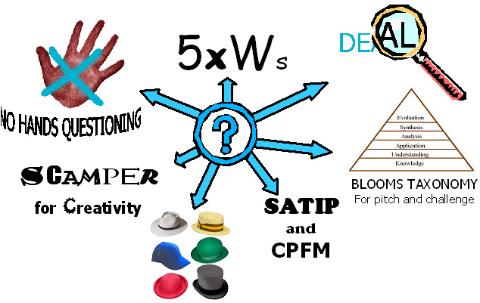
Effective Questioning
to promote learning, foster higher
order thinking, develop imagination,
creative thinking and pitch challenge

Asking questions is natural and intuitive. As teachers, we ask questions as soon as the lesson starts and continue until the end. Asking questions forms part of any lesson because it invites the student to think, and even within a ‘lecture’ style lesson, rhetorical questions are used to invite silent agreement or begin the organisation of ideas to present a response.

Teachers use questions to engage the students and sustain an ‘active’ style to the learning. The teacher also uses questions as part of the assessment of learning in order to determine how they best structure, organise and present new learning. However, research has found that most teachers only wait 0.7seconds for an answer. Developing questioning, requires much greater emphasis on the time provided for students to think individually, collaboratively and deeply to develop and share better answers.

Historically, teachers have asked questions to check what has been learnt and understood, to help them gauge whether to further review previous learning, increase or decrease the challenge, and assess whether students are ready to move forward and learn new information. This can be structured as a simple ‘teacher versus the class’ approach, where the teacher asks a question and accepts an answer from a volunteer, or selects/conscripts a student to answer. These approaches are implicit in any pedagogy, but teachers need a range of questioning strategies to address different learning needs and situations.

This paper encourages teachers to plan their questioning approaches, prepare the most important questions and pre-determine the level of challenge they wish to set.

How and why do we use Questions in the classroom?
Teachers use questioning as part of their teaching for many reasons, but often to:

- maintain the flow of the learning within the lesson
- engage students with the learning
- assess what has been learned
- check that what has been learnt is understood and can be used
- test student memory and comprehension
- seek the views and opinions of pupils
- provide an opportunity for pupils to share their opinions/views and seek responses from their peers
- encourage creative thought and imaginative or innovative thinking
- foster speculation, hypothesis and idea/opinion forming
- create a sense of shared learning and avoid the feel of a ‘lecture’
- challenge the level of thinking and possibly mark a change to a higher order of thinking
- model higher order thinking using examples and building on the responses of students

All the following examples and many others are useful and necessary within different classroom situations. They help teachers move students from simple responses, to engage in more developed complex thinking. This helps them apply what they understand, to bridge learning from other times and different situations, to think more actively in lessons and learn from each other’s answers.
Questioning approaches e.g. ‘thinking time’, the ‘no hands’ rule and ‘phone a friend’
Strategy/approach | Process | Gains and benefits
Thinking Time:  Consciously waiting for a pupil or class to think through an answer (before you break the silence) e.g 15-30secs | Provide time between setting the question and requiring an answer. Sometimes alerting pupils to the approach and the time available to develop an answer. | Prompts depth of thought and increases levels of challenge. Ensures all pupils have a view or opinion to share before an answer is sought.
No Hands Questioning:  Using the ‘no hands up’ rule  Ref. AfL publication - Working Inside the Black Box. | Pupils aware that those required to give an answer, will be selected by the teacher. Teachers alert them to this as questions are asked.  Linked to ‘thinking time’. | Improves engagement and challenges all pupils to think. When linked to Thinking Time, pupils share ideas and ‘position’ their own views in relation to others.
Basketball questioning:  Move questions and discussions between pupils | Teacher establishes movement of ideas and responses around the class. Builds on other pupils’ ideas and comments. Accepts ‘half-formed’ ideas. NB not ‘ping-pong’ | Engages more pupils. Stops teacher being focus for all questioning. Develops connected thinking and development of ideas.
Conscripts and Volunteers:  Using a planned mix of ‘conscripts’ and ‘volunteers’ | Teacher selects answers from those who volunteer an answer and an equal amount of those who do not. | Enhances engagement and challenge for all.
Phone a friend:  Removes stress to enable those who cannot answer to participate | Those who cannot answer are allowed to nominate a fellow pupil to suggest an answer on their behalf, but they still have to provide their own answer, perhaps building on this. | Encourages whole-class listening and participation. Removes stress and builds self-esteem.
Hot-seating: | A pupil is placed in the ‘hot-seat’ to take several questions from the class and teacher. | Encourages listening for detail and provides challenge
Mantle of the expert: | A wears the cloak of the expert to answer questions from the class. | Builds self-esteem through opportunity to share detailed knowledge.
Preview:  Previewing questions in advance | Questions are shared/displayed before being asked, or the start of the lesson. | Signals the big concepts and learning of the lesson
Pair rehearsal:  of an answer or a question | Pairs of pupils are able to discuss and agree responses to questions together. | Encourages interaction, engagement and depth
Eavesdropping:  Deploying specific targeted questions | Listen in to group discussions and target specific questions to groups and individuals. | Facilitates informed differentiation.
5Ws:  Modeling simple exploratory questions to gather information | Teacher models the use of Who, What, Where, When and Why to set out a simple information gathering response based on the information provided. | Encourages students to rehearse enquiry and comprehension, can extend into reasoning and hypothesis.  Creates an inquisitive disposition and a thinking/self reflective approach to learning.


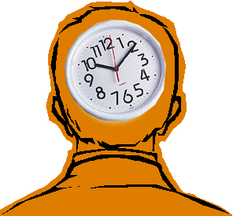

Strategy/approach | Process | Gains and benefits
High Challenge:  Phrasing questions carefully to concentrate on Bloom’s Taxonomy higher challenge areas | Questions must be pre-planned, as very difficult to invent during a lesson. Focus questions to address analysis, synthesis, evaluation and creativity, based on Bloom’s Taxonomy. | Provides high challenge thinking, requiring more careful thought, perhaps collaborative thinking and certainly longer more detailed answers. For Able, Gifted and Talented.
Staging or sequencing: questions with increasing  levels of challenge | Increasing the level of challenge with each question, moving from low to higher-order questioning | Helps pupils to recognise the range of possible responses and to select appropriately.
Big questions:  The setting of a substantial and thought provoking question | Big questions cannot be easily answered by students when the question is posed. They are often set at the beginning of the lesson and can only be answered by the end of the lesson, using all of the thinking based on all of the contributions to the lesson. | These questions develop deeper and more profound thinking. Big Questions are often moral issues or speculative questions such as, Where are we from? How big is the universe? What is the meaning of life?  They require extended answers and usually rely on collaborative thinking and a personal interpretation of the information provided.
Focus questioning:  This will help students to answer bigger questions | When students struggle to answer bigger or more complex questioning, the teacher can model or lead the thinking by asking Focus questions to lead the student through the steps of the thinking. | Develops confidence and the sequencing of small steps in thinking and response. Allows students to reveal the stages in their thinking.
Fat questions:  Seeking a minimum answer | Pupils are not allowed to answer a question using less than e.g. 15 words or using a particular word or phrase. They must give an extended answer or make a complete sentence/phrase. | Develops speaking and reasoning skills, the correct use of critical and technical language .
Skinny questions  A traditional approach to Q&A asking everyday questions with a fixed or specific answer | In its simplest form, students can answer yes or no to a skinny question, or give a number or knowledge based response. | Challenge level is low in skinny questions that do not seek and extended answer or reasons for the answer. Mostly knowledge and comprehension based. Does not develop thinking or reasoning.
Signal questions: | Providing signals to pupils about the kind of answer that would best fit the question being asked. Teacher responds to pupils attempt to answer, by signaling and guiding the answers. | The essence of purposeful questioning, moving pupils from existing knowledge or experience (often unsorted or unordered knowledge) to organized understanding, where patterns and meaning have been established.
Seek a partial answer: | In the context of asking difficult whole class questions, deliberately ask a pupil who will provide only a partly formed answer, to promote collective engagement. | Excellent for building understanding from pupil-based language. Can be used to lead into ‘Basketball questioning’. Develops self-esteem.

Many of these teaching approaches are taken from the National Secondary Strategy for School Improvement ‘Questioning’ Unit of the Foundation Strand materials and Assessment, or from the work of members of the AfL team including Paul Black and Christine Harrison.

5xWs
The Five Ws, also known as the Five Ws (and one H), is a concept used in journalism, research and in Police Investigations that most people consider to be fundamental when examining any new learning sitation. It is a formula for getting the "full" story on something. The maxim of the Five Ws (and one H) is that in order for an analysis of basic facts and information to be considered complete it must answer a checklist of six questions, each of which comprises an interrogative word:

Who? What? Why? Where? When? & How?

The principle underlying the maxim is that each question should elicit a factual answer — facts that it is necessary to include for a report to be considered complete. Importantly, none of these questions can be answered with a simple "yes" or "no".

The technique uses basic question generating prompts provided by the English language. The method is useful at any level from a formal checklist to complete informality.
For example:
- For informal ‘rough-book’ use as a quick-aide checklist, as a private checklist to keep in mind when in an on going discussion, as quick points scribbled down in a lesson, to generate further questions for yourself or to raise in the lesson with your group/whole class.
- To generate data-gathering questions in any subject, during the early stages of problem solving when you are gathering data, the checklist can be useful either as an informal or systematic way of generating lists of question that you can try to find answers for.
- To generate idea-provoking questions, whilst brain-storming, brain-writing or some other such similar technique, the checklist could be used as a source of thought provoking questions to help build on existing ideas.
- To generate criteria, the checklist could help in generating criteria for evaluating options.
- To check plans, the checklist is a useful tool for planning implementation strategies.

Adding IWWM – In What Way Might ….
NB: The 5xWs and How ‘question words’ owe their strength to their fundamental place in the English language, and can conceal some of the assets of nature that our language copes less well with. The responses to these questions in the checklist are usually facts, rather than actions or conclusions. You may well need to link these questions to Blooms Taxonomy if you want to achieve the correct level of challenge or use IWWM.
- For example, the answer to ‘Who does X?’ in a History lesson context could be ‘King …’. To use this answer in a problem-solving or conclusion finding context you may have to take this to another level of challenge.
- For example ‘OK – if King … does X, in what way might we conclude this was a wise action by him and his court?
- This ‘in what way might’ (IWWM) stage is crucial if the facts are to come alive and contribute to the creative thinking process.

Questions | Conclusions / Hypothesis
Who … ?
What … ?
Why … ?
When … ?
Where … ?
How … ?
In What Way Might … ?
“Dialogic teaching harnesses the power of talk to stimulate and extend children’s thinking,
and to advance their learning and understanding. It also enables the teacher to diagnose and assess. Dialogic teaching is distinct from the question-answer-tell routines of so-called ‘interactive’ teaching, aiming to be more consistently searching and more genuinely reciprocal and cumulative.”
Robin Alexander

Dialogic Teaching

Dialogic teaching provides a strategy for managing and assimilating many aspects of the other approaches to developing classroom talk, identified elsewhere in this paper.

Dialogic teaching harnesses the power of talk to engage children, stimulate and extend their thinking, and advance the learning and understanding. Not all classroom talk secures these outcomes, and some may even discourage them. Dialogic teaching, therefore, is:

- Collective: teachers and children address learning tasks together, whether as a group or as a whole class;
- Reciprocal: teachers and children listen to each other, share ideas and consider alternative viewpoints;
- Supportive: children articulate their ideas freely, without fear of embarrassment over ‘wrong’ answers; and they help each other to re ach common understandings;
- Cumulative; teachers and children build on their own and each others’ ideas and chain them into coherent lines of thinking and enquiry;
- Purposeful: teachers plan and steer classroom talk with specific educational goals in view.

Most teachers use a basic repertoire of three kinds of classroom talk:
  - rote
  - recitation
  - instruction/exposition
These provide the bedrock of repertoire of teaching by direct instruction, but some teachers also use:
  - discussion
  - scaffolded dialogue

These all have their place in a thinking classroom, but Dialogic talk is part of a larger repertoire, needed to ensure children are empowered both in their learning now and later as adult members of society.

As part of their cognitive development, children need to acquire the capacity to:
- narrate,
- explain
- instruct,
- ask different kinds of questions,
- receive, act and build upon answers
- analyse and solve problems
- speculate and imagine
and, in order that they can do this effectively with others:
- listen
- be receptive to alternative viewpoints
- think about what they hear
- give others time to think.
- explore and evaluate ideas
- discuss
- argue, reason and justify
- negotiate

AS part of a comprehensive classroom approach to talk for learning and empowerment, teachers will need to engage with both of these repertoires, through:
Teacher-pupil interaction, Pupil-pupil interaction, Teacher-pupil one-to-one monitoring, Questioning, Responses to questioning, Feedback on responses, Pupil talk.

Text and principles taken from: Towards Dialogic Teaching – Rethinking classroom talk
Robin Alexander – ISBN 0-9546943-0-9 Published by Dialogos UK Ltd
Tools for questioning to engage and encourage the exploration of ideas to develop a particular thinking

Pose, Pause, Pounce & Bounce
A strategy for structuring questioning in the classroom, to ensure thinking time, selection of students to answer and collaborative sharing of ideas and response.
Pose – Teacher poses the question as a big question for all to consider and form a response to.
Pause – Teacher gives thinking time and possibly discussions/thinking together.
Pounce – Teacher selects who will provide and answer (no hands and not hands up).
Bounce – Teacher ‘bounces’ the answers from student to student developing the ideas/encouraging all to add their views or extend the e.g. depth and breadth of answers.

D E A L
DEAL is often used in science to explore:
- ideas about what is seen (experiments or phenomenon)
- to develop the thinking and analyse these perceptions
- make links with previous learning and convey understanding
- develop the ability to apply what has been learnt
- make connections with other areas of previous learning.
D | Describe | Describe what you see, experience and can measure
E | Explain | Explain what you know or understand, what you experienced or think happened
A | Analyse | Analyse the information or evidence to draw conclusions or determine what you believe is happened and why
L | Link | Link with previous knowledge or make connections with other phenomenon or outcomes where these connections bring further conclusions or lead to hypothesis

SATIP
A strategy for beginning to engage with ‘Reading’ any text. This develops in the reader, further questions in order that they then form a sense of meaning from the text, to develop understanding and before the teacher might use Blooms Taxonomy to set more challenging questions.
- Sense – or meaning – what is it about?
- Audience – or tone – who is it intended for?
- Technique – what are the techniques that have been used - what is their effect?
- Intentions – What was the writer’s purpose?
- Personal opinion – what is your reaction – what do you start to conclude?

C | Content | Analyse and describe the Content. This refers to much more than the subject matter of a work of art. It can manifest itself in three overlapping ways. What the piece of work represents or symbolises, what story or event is portrayed (referred to as narrative content), and what idea the artist is attempting to pursue.
P | Process | Analyse and describe the Process. This refers to the way in which media and materials have been used to formulate and create a particular piece of work. This could refer to a single process or a sequence of processes that have been combined to create the final outcome or work of art.
F | Form | Analyse and describe the use of the artistic, ‘formal’ elements or elements that make up that artform. These can be described in simple terms as the building blocks for the artform, e.g in Art and Design: line, tone, colour, pattern, texture, shape, form and space
M | Mood/ emotion | Analyse and describe the Mood. This refers to the way in which the artist has handled form and subject matter to create an emotionally affective piece of work. How the piece of work makes the person experiencing the artform feel, and the viewer being able to find evidence in the piece of work to support this feeling.
C P F M - Content, Process, Form and Mood
A guide to Critical Studies and how to look at, think and talk about objects, images and works of art, craft and design. Rod Taylor (Educating for Art -Critical Response and Development, SCDC Publications 1986)

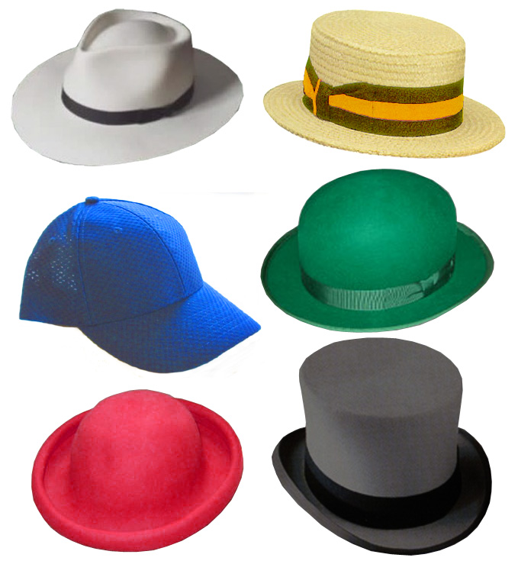
The Six Thinking Hats

developed by Edward de Bono
“Thinking is a skill, intelligence is not enough.”

“Within the information age – using the Internet to find information is not enough, you have to think about what you find.”
Edward de Bono

When using the six thinking hats, we move thinking away from an emphasis on criticism and judgement, towards the direction of creative or constructive thinking. This is achieved by considering six different modes of thought, each shared by the thinkers together at the same time. They do not each consider different modes at the same time. Hence, the thinking is in parallel.

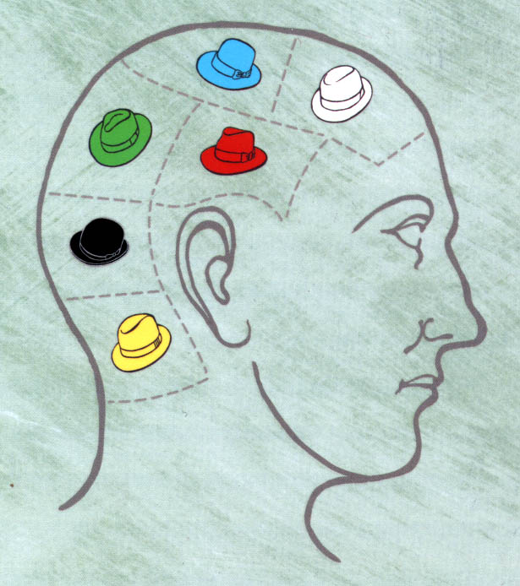
The six hats represent six modes of thinking and are directions to think rather than labels for thinking. That is, the hats are used proactively rather than reactively.

The method promotes fuller input from more people. In de Bono's words it "separates ego from performance". Everyone is able to contribute to the exploration without denting egos as they are just using the yellow hat or whatever hat. The six hats system encourages performance rather than ego defence. People can contribute under any hat even though they initially support the opposite view.

The Six Thinking Hats system has four specific uses:
- It’s a critical meeting facilitation tool
- It’s an outstanding team productivity/communication tool
- It’s a creativity enhancer
- It’s a control mechanism used to maximize and organize a person’s thoughts (help make decisions and solve problems).

Thinking is separated into six distinct categories. Each category is identified with its own coloured metaphorical "thinking hat.” By mentally wearing and switching “hats,” you can easily focus or redirect thoughts, the conversation, or the meeting. The difference between brilliant and mediocre teams and group activity, lies not so much in their collective mental equipment, but in how well they use it and how well they work together. It artificially allows people to switch thinking quickly.

There is a range of methodology:
- There are six metaphorical hats and the thinker can put on or take off one of these hats to indicate the type of thinking being used.
- When done in-group, everybody wears the same hat at the same time.
- The hats must never be used to categorize individuals, even though their behaviour may seem to invite this.
- This putting on and taking off is essential.
- Hats can be used individually – as symbols to request a particular type of thinking i.e. …”I think we need some green hat thinking here.”
- Hats can be used in a sequence e.g. Blue, Any, Any, Any, Any, Any, Blue – any hat can be used as often as you like, There is no need to use every hat; the sequence can be made up of two, three, four or more hats; there are two broad types of sequence: evolving and pre-set.
- Evolving – facilitator chooses first hat and when this hat is completed, the next hat is chosen and so on (but this process needs to avoid manipulation and users need to be very experienced)
- Pre-set sequences - is set up at the beginning of the meeting, under an initial blue hat. Minor variations can be permitted, depending on output.


The White Hat
The White Hat calls for information known or needed.
This covers facts, figures, information needs and gaps. "I think we need some white hat thinking at this point..." means Let's drop the arguments and proposals, and look at the data base."


The Yellow Hat
The Yellow hat symbolizes brightness and optimism, benefits, value sensitivity. This is the logical positive. Why something will work and why it will offer benefits. It can be used in looking forward to the results of some proposed action, but can also be used to find something of value in what has already happened.
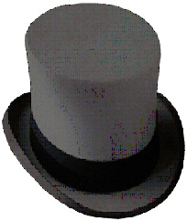
The Black Hat
The Black hat is judgment—the devil’s advocate or why something may not work, risk assessment, caution. It is most useful, but can be over used.
This is a most valuable hat. It is not in any sense an inferior or negative hat. The black hat is used to point out why a suggestion does not fit the facts, the available experience, the system in use, or the policy that is being followed. The black hat must always be logical.


The Red Hat
The Red Hat signifies feelings, intuition, hunches, and emotion – gut feelings.
The red hat allows the thinker to put forward an intuition without any need to justify it. "Putting on my red hat, I think this is a terrible proposal." Usually feelings and intuition can only be introduced into a discussion if they are supported by logic. Usually the feeling is genuine but the logic is spurious. The red hat gives full permission to a thinker to put forward his or her feelings on the subject at the moment.

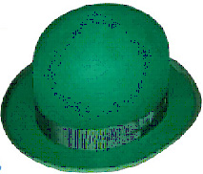
The Green Hat
The Green hat focuses on creativity: the possibilities, alternatives, and new ideas, growth, energy, hypothesis. (Too little time is spent on this at present). This hat explores what is interesting, provocations and changes.


The Hat
The Blue Hat is used to manage the thinking process (metacognition).This is the overview or process control hat. It looks not at the subject itself but at the 'thinking' about the subject. "Putting on my blue hat, I feel we should do some more green hat thinking at this point." In technical terms, the blue hat is concerned with meta-cognition.

Using the six hats in the classroom
The six hats are used by teachers to structure a sequence of questions and discussions between small groups of students or a whole class. Teacher’s best lead the discussions by wearing the blue hat and managing the sequence in the wearing of the hats. You may use the following sequence of hats to help you phrase your questions.

- It is typical to begin the process of discussions by asking students a question that asks them to wear the red hat and share their emotional response to the issue under discussion. The question may encourage them to share their ‘gut feelings’ or intuition.
- This first phase is often followed by a white hat question, which calls for the sharing of information or data that can inform the students and make them more aware of any information pertinent to the issue under discussion. This builds on their emotional response.
- The next phase of questioning usually uses the green hat to ask students to explore creative possibilities.

- This is then followed by either the black hat which explores potential problems with the green hat suggestions.
- Alternatively, a yellow hat question might explore optimistic ideas or explore the value of the green hat ideas already suggested.
- The blue hat can be called for by the students or the teacher can offer the blue hat to the students to invite them to suggest whether any of the hats should be worn again, to focus any further questions.

Creative questioning using SCAMPER
SCAMPER, devised by American Bob Eberle, is a useful technique to extend all pupils' thinking and can provide real imaginative opportunities to all pupils to extend their work. The SCAMPER technique uses a set of directed questions which pupils answer in order to come up with new ideas. The stimulus comes from answering questions that you (as a teacher) and pupils (as learners) would not usually ask. It helps pupils to ask questions that require them to think 'out of the box', helping to develop their critical thinking skills. It's also a useful tool for creative writing and a stimulus for role play.

- Remember, you don't have to use all the steps in SCAMPER.
- Use it to spark off creative development and then let pupils work on their own. If they get stuck, they can return to the SCAMPER framework.

Scamper is reproduced from issue 14 of the Primary focus G&T Update magazine

Other uses for SCAMPER
SCAMPER makes a good starter activity for all sorts of lessons.
- Show pupils an object (probably from a school or museum collection) and ask them to use the SCAMPER technique to come up with uses for the object.
- Show or project in large scale for pupils an image (probably taken from the web or an illustration from a book) and ask them to use the SCAMPER technique to come up with descriptions of alternative images relating to the SCAMPER technique

SCAMPER is an acronym that stands for a series of questions to ask about a familiar piece or work or process:
S | Substitute | Substitute one aspect of your product/process  What else instead? Who else instead? Other ingredients? Other material? Other power? Other place?
C | Combine | Combine two or more parts with something else  How about a blend, an alloy, an ensemble? Combine purposes?
A | Adapt | Adapt or alter one aspect  What else is like this? What other idea does this suggest? Does past offer parallel? What could I copy?
M | Modify (distort or) Magnify | Change part/all of the current situation  Order, form, shape? What to add? More time? Greater frequency? Higher? Longer? Thicker?
P | Put to other purpose | How could you put your current item/process to another use?  What else could I use this for? New ways to use as is? Other uses I modified? Other places to use?
E | Eliminate | Delete one aspect  What would happen if I got rid of something? What difference would this make? What to subtract? Smaller? Condensed? Miniature? Lower? Shorter? Lighter? Omit? Streamline? Understate?
R | Reverse | Reverse one thing  What if I did it the other way round? What if I reverse the order it is done or the way it is used? How would I achieve the opposite effect? Other sequence? Transpose cause and effect? Change pace? Transpose positive and negative? How about opposites? Turn it backwards? Turn it upside down? Reverse roles?
Bloom's Taxonomy
Higher order questioning in the context of looking at works of art and reading

In 1956, Benjamin Bloom headed a group of educational psychologists who developed a classification of levels of intellectual behaviour important in learning. Bloom found that over 95 % of the test questions students encounter require them to think only at the lowest possible level...the recall of information.

Bloom identified six levels within the cognitive domain, from the simple recall or recognition of facts, as the lowest level, through increasingly more complex and abstract mental levels, to the highest order, which is classified as evaluation. Verb examples that represent intellectual activity on each level are listed below.

Evaluation

Synthesis

Analysis

Application

Understanding

Knowledge

Creativity

- Knowledge: arrange, define, duplicate, label, list, memorize, name, order, recognize, relate, recall, repeat, reproduce state.
- Comprehension: classify, describe, discuss, explain, express, identify, indicate, locate, recognize, report, restate, review, select, translate,
- Application: apply, choose, demonstrate, dramatize, employ, illustrate, interpret, operate, practice, schedule, sketch, solve, use, write.
- Analysis: analyze, appraise, calculate, categorize, compare, contrast, criticize, differentiate, discriminate, distinguish, examine, experiment, question, test.
- Synthesis: arrange, assemble, collect, compose, construct, create, design, develop, formulate, manage, organize, plan, prepare, propose, set up, write.
- Evaluation: appraise, argue, assess, attach, choose compare, defend estimate, judge, predict, rate, core, select, support, value, evaluate.
Creativity: imagine, invent, resolve, investigate, explore, create, originate, innovate
This guidance is intended to help teachers to order and phrase suitably challenging questions when using works of art, craft and design to inform and develop pupils thinking and response, to inform the development of their ideas, imagination and creativity. Creativity has been added above Evaluation as a higher order thinking activity, since Bloom first developed the taxonomy. This has been proposed also by the national secondary strategy as a suitable addition.

As teachers we tend to ask questions in the "knowledge" category 80% to 90% of the time. These questions are not bad, but using them all the time is. Try to utilize a higher order level of questions. These questions require much more "brain power" and a more extensive and elaborate answers. On the next page are the six question categories as defined by Bloom.

BLOOMS TAXONOMY
Competence | Skills Demonstrated | Question Cues:
Knowledge | - observation and recall of information  - knowledge of dates, events, places  - knowledge of major ideas  - mastery of subject matter | list, define, tell, describe, identify, show, label, collect, examine, tabulate, quote, name, who, when, where, etc.
Comprehension (understanding) | - understanding information  - grasp meaning  - translate knowledge into new context  - interpret facts, compare, contrast  - order, group, infer causes  - predict consequences | summarize, describe, interpret, contrast, predict, associate, distinguish, estimate, differentiate, discuss, extend
Application | - use information  - use methods, concepts, theories in new situations  - solve problems using required skills or knowledge: | apply, demonstrate, calculate, complete, illustrate, show, solve, examine, modify, relate, change, classify, experiment, discover
Analysis | - seeing patterns  - organization of parts  - recognition of hidden meanings  - identification of components | analyze, separate, order, explain, connect, classify, arrange, divide, compare, select, explain, infer
Synthesis | - use old ideas to create new ones  - generalize from given facts  - relate knowledge from several areas  - predict, draw conclusions | combine, integrate, modify, rearrange, substitute, plan, create, design, invent, what if?, compose, formulate, prepare, generalize, rewrite
Evaluation | - compare and discriminate between ideas  - assess value of theories, presentations  - make choices based on reasoned argument  - verify value of evidence  - recognize subjectivity | assess, decide, rank, grade, test, measure, recommend, convince, select, judge, explain, discriminate, support, conclude, compare, summarize
Adapted from: Bloom, B.S. (Ed.) (1956) Taxonomy of educational objectives: The classification of educational goals: Handbook I, cognitive domain. New York ; Toronto: Longmans, Green.

Example of the use of Bloom's Taxonomy for planning questions - Looking at, thinking and responding to a work of art and design
PURPOSE | To apply Bloom's theory of developing higher levels of thought processes to looking at, thinking and talking about works of art, craft and design.
EXPLANATION | Typically when learning about art and design, students are encouraged to look at works of art, to develop their understanding of the artist, the period or movement and an understanding of process, technique, content the artistic form and emotional response or mood evoked by the work. Judgements are often subjective and operate principally at a level of knowledge and understanding. Students are encouraged to evaluate their views, but are more rarely taken beyond comprehension and through the intermediate stages of application, analysis and synthesis. This focus is limiting because the purpose of looking at works of art is principally twofold.  - Firstly, we wish to enrich and enhance the quality of life of students, to develop their cultural understanding.  - Secondly, we hope to develop students own visual literacy skills and their ability to look and think, to develop their own response to art works which will in turn inform their own imagination and ideas for their own art making. This should assist students in their learning about technique, process, composition, use of mark, shape, colour, organisation of content and elements, the use of signs and symbols or cultural references and ultimately meaning.  Questions that teachers ask can direct students to the realisation that visual literacy has a greater purpose than just acquiring facts about an artist. It is hoped that students can learn to ‘read’ a work of art and make connections between the work they are viewing and other art works they have seen at different times, or between other art forms and other areas of learning. Higher order questioning can lead pupils to make these ‘connections’ leading to a more developed or imaginative response, which will in turn establish it as a life-long habit and enrich the experience of looking at works of art.
PROCEDURE | For any identified visual literacy activity, develop questions that reflect the progression of thinking and responding from the literal (descriptive) level to the evaluative. Not all levels need to be developed for every art work. Consider a range that will lead the pupil to the greater purpose of looking and responding.  Each level of Bloom’s original taxonomy has been restated for clarity and simplification. Examples of appropriate questions or directives are given to illustrate each level. The familiar portrait Anna Christina by Andrew Wyeth has been used to assist understanding and enable the exemplification.

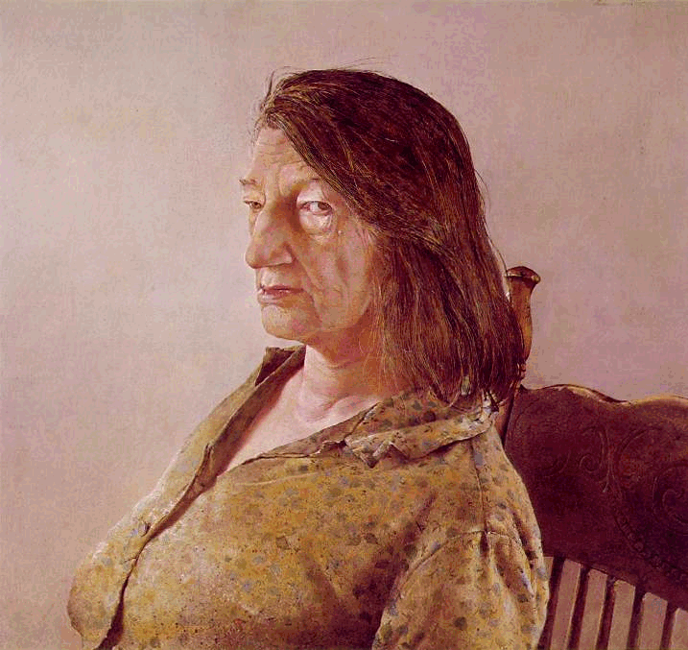

Anna Christina by Andrew Wyeth
1967
Tempera
21 1/4 x 23 1/2 in
Museum of Fine Arts, Boston

Wyeth has remained visually and emotionally attached to the real world, a world all but forgotten by his contemporaries and the 20th Century. The importance of this cannot be over-estimated. In this way, Wyeth has served as a link with the great tradition of artists responsive to life and humanity that was essentially severed following the Post-Impressionists, and which is now in the early stages of resumption.

Wyeth reacts to and expresses the character of the people whose lives he has passed through and shared. He searches out the pose, the look in the eye, the set of the mouth, the significant facial wrinkle, the sweater out at the elbow, the signals a dress gives when it has been worn a thousand times, retaining the form and postures of the wearer.

He sees significance in the simplest objects, implements, animals and landscapes of a rural life. A basket, a stump, a hound, an egg-scale, a hillside painted by Wyeth contain a meaning, rising to the level of symbol, which is a blend of the meaning -- poetic and divine -- inherent in all things in life, and the depth of Wyeth's emotional response and visual commitment to them. Wyeth's sensitivity, perception and symbolic intensity elevated him, above the run-of-the-mill illustrator-artist.

Another version of Christina Olson, the painting "Anna Christina," 1967, depicting her sitting against a foggy background, is a marvelous character study emphasizing a prominent, hooked nose, eyes that pull against each other as one looks toward the viewer, a jutting lower lip and weathered cheek. But it just doesn't hold up as a solid head. It is again the extraordinarily talented illustration of a head, rather than the three-dimensional re-creation of a head in the sense of Rembrandt, Vermeer, Cezanne, etc.

These questions are designed to develop higher order thinking in response to this painting and several others by the artist Andrew Wyeth, in preparation by pupils who are planning to make a painting of an elderly relative.

Knowledge | the recall of specific information  - Who was Andrew Wyeth?  - Where did he live? And what country do his paintings depict?  - Who is the person in the painting?  - What is Tempera?
Comprehension | an understanding of what has been viewed and of other work by the artist  - What sorts of scenes are depicted in the Andrew Wyeth paintings you have seen?  - What kind of painting is this?  - Where might this picture have been painted or where did the sitter pose?  - What can you tell us about the person in the picture, just by looking and thinking?  - Can you suggest what Anna Christina might do?
Application | the converting of abstract content to concrete situations – applying what is know and understood to real situations  - Can you describe the way in which the artist will have organised the room for the portrait to be painted?  - If you were to use the same pose in your painting of an elderly relative, then what would you include in your painting to tell us about your relative?  - How might your painting be different?  - How long do you think the sitter had to pose for the portrait? Could you sit still for that amount of time? How do you think the artist might have organised the blocks of time for each sitting?  - Can you describe the stages the artist may have gone through from start to finish to complete this painting?
Analysis | the comparison and contrast of the content to personal experiences  - What kind of person do you think Anna Christina is?  - How would you react if you met her?  - Can you compare Anna Christina to a member of your own family?  - Do you think the painting is an honest description of the person?  - Do you know anyone who this painting reminds you of? Describe that person?  - If you heard Anna Christina talking – what would she sound like?
Synthesis | the organization of thoughts, ideas, and information from the content  - What do you think the sitter (Anna Christina) is thinking?  - If you were to pose for a portrait, what would you think about, to pass the time?  - Draw a selection of compositional studies to show how you would use a similar informal pose if you were planning to make a painting of an elderly relative. Try to include the actual chair they would sit in and the background of the room where they would pose and where you would make the painting.  - Make a list of the things you would want to include in your painting.  - Describe what your posing figure would look like if viewed from several different viewpoints around them. Make some sketches if this would help you.  - What other way could you make a portrait, that tells us more about the person in the picture?
Evaluation | the judgment and evaluation of characters, actions, outcome, etc., for personal reflection and understanding  - Do you think Anna Christina is a real person?  - Why do you think Andrew Wyeth wanted to paint this portrait?  - What does the style of painting tell you about Anna Christina?  - What do you think the clothes she is wearing and the chair she is sitting in, tell you about her?  - Do you think this is an honest painting?  - Would you want to make your painting of an elderly relative like this painting by Andrew Wyeth? or how would you make it different ?  - How does this portrait compare with others you have seen?  - Why do artists make portraits and not just take photographs of people to exhibit?

