A Step-by-step guide to setting up a Drop Box Account

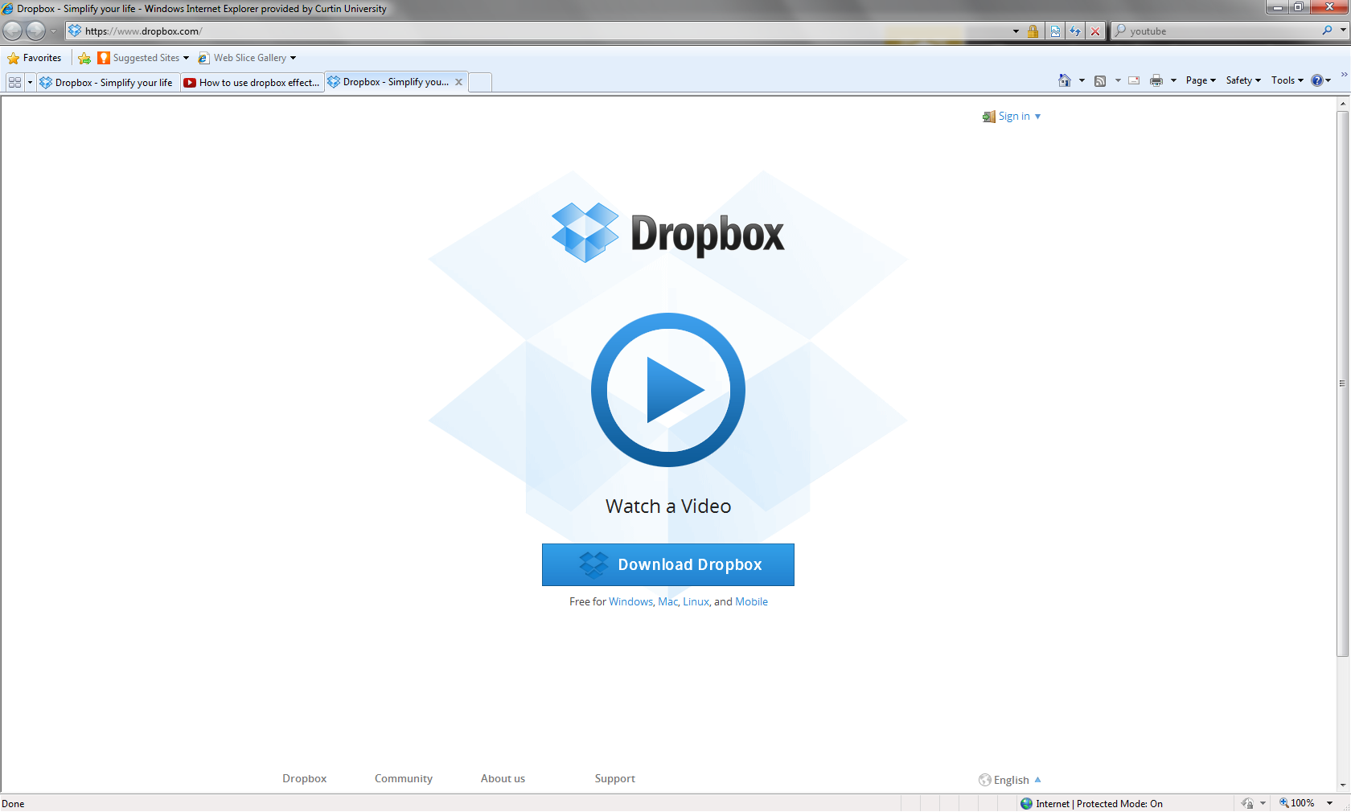 | Creating your DropBox Account  Go to www.dropbox.com  Wath the introductory video to give you an ovedrview of DropBox
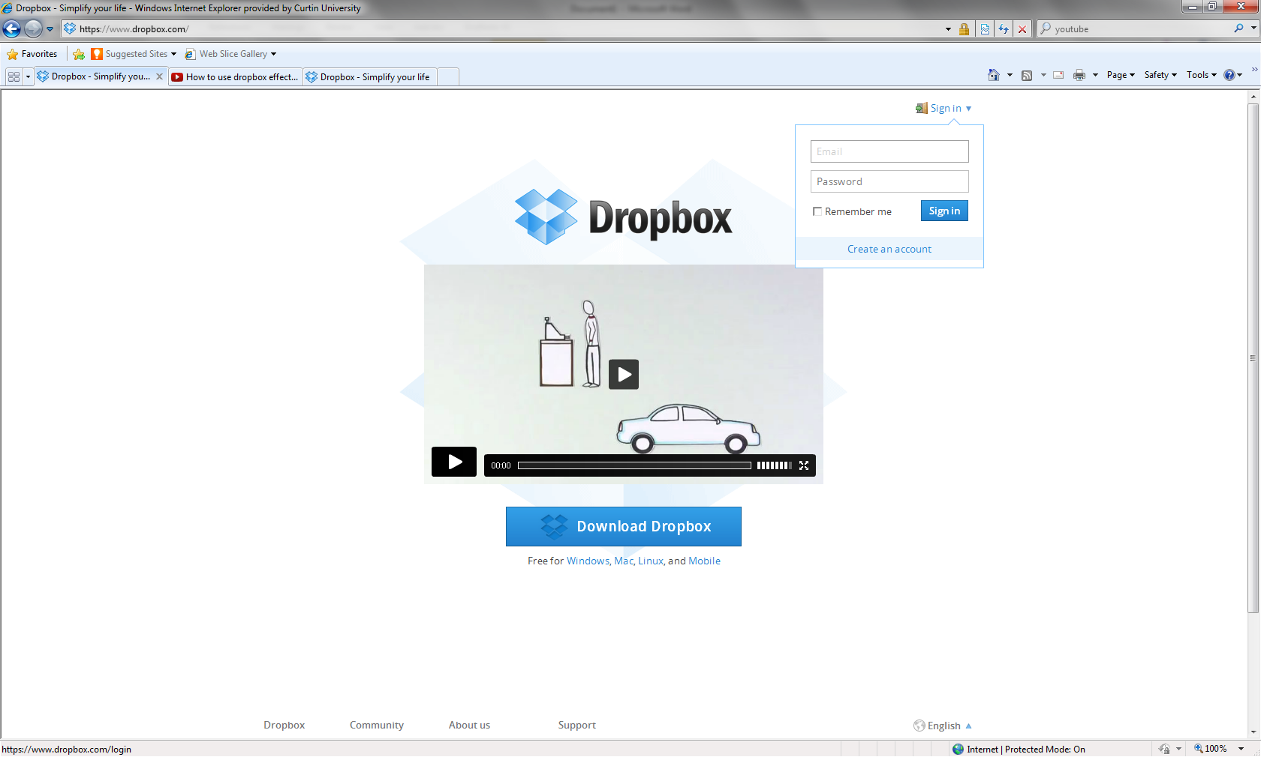 | Go to the sign in section and click on Create an Account
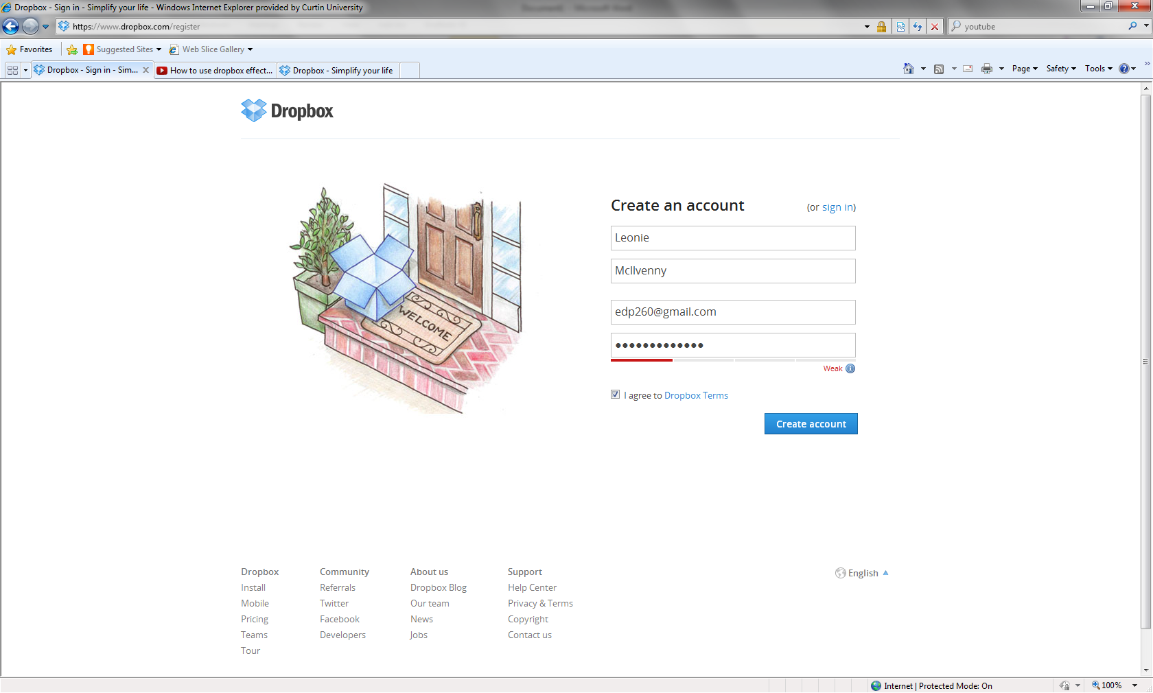 | Fill in your Registration details
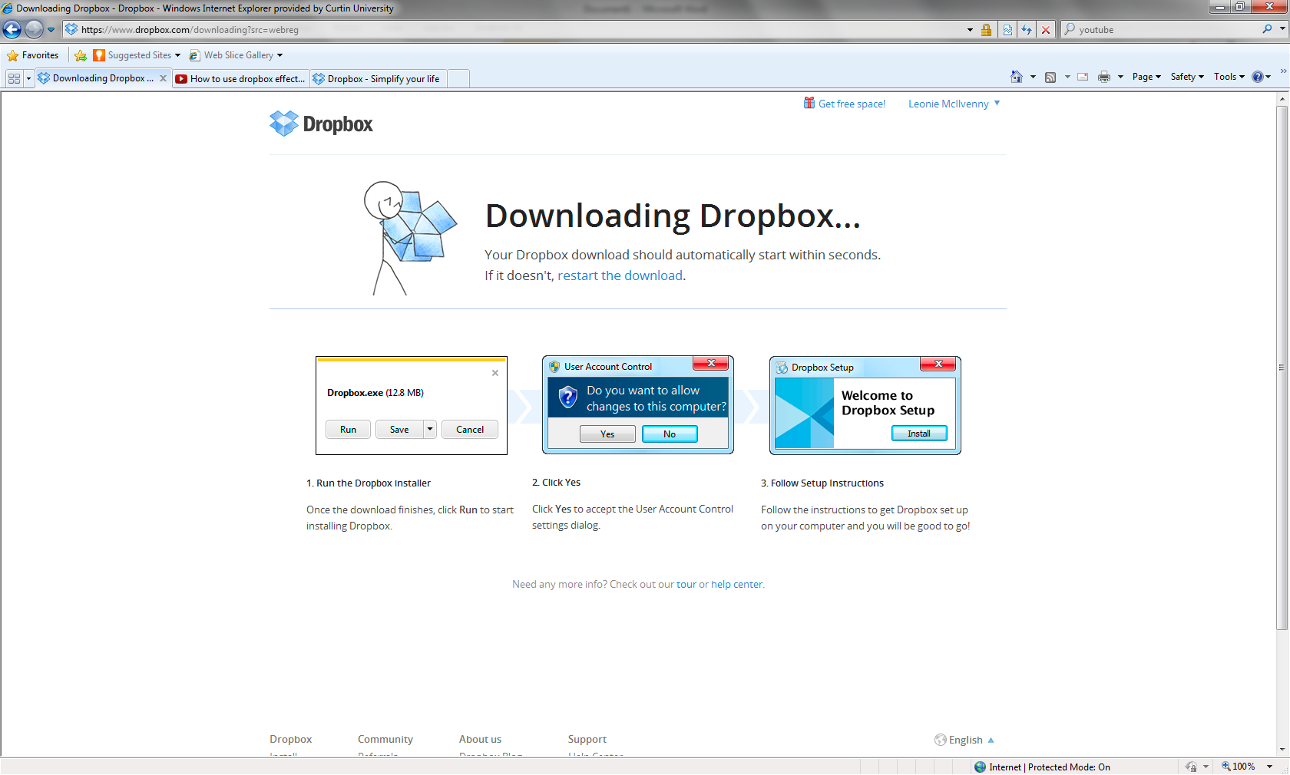 | Installing Dropbox on your computer  Follow the prompts to install DropBox on your computer

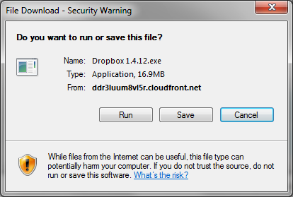 | Select RUN to install Dropbox on your computer
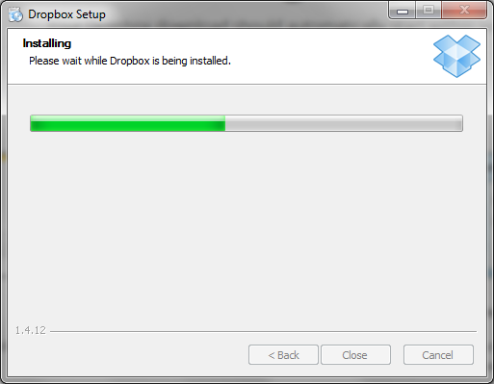 | The system will show the progress of the installation.  Once Dropbox is installed it may appear:  as an icon either at the bottom of your screen  in the Finder menu of Apple under your Applications  or a a Favourite on the your PC
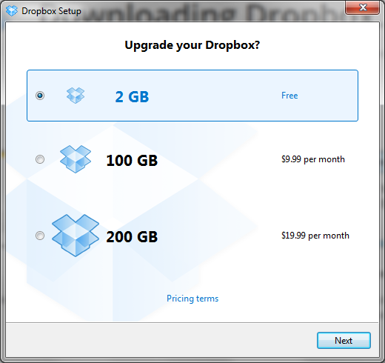 | Opening Dropbox  When you click on the Dropbox icon you will be given the option of choosing how much storage space you would like. Select 2gb as ithis will be enough for the unit (you can buy more space at a later date if you wish).
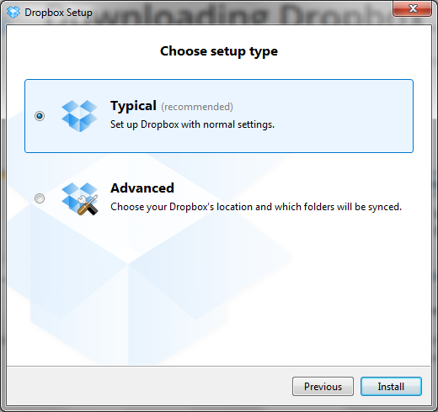 | Select Typical set up type

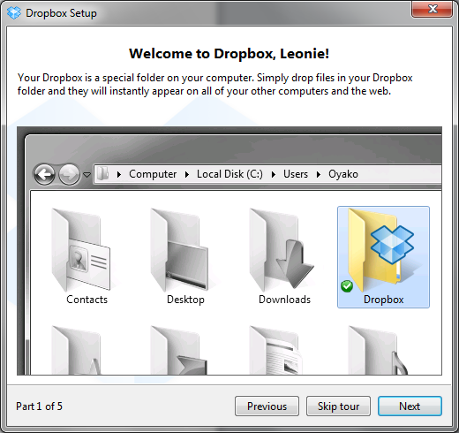 | A Guided Tour  These next windows are part of the guided tour to show you a bit about Dropbox – you can skip them if you wish.
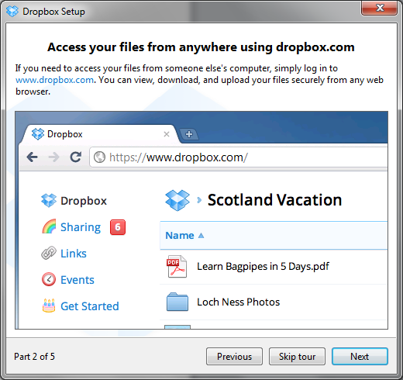

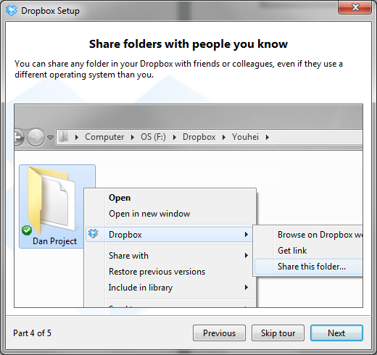

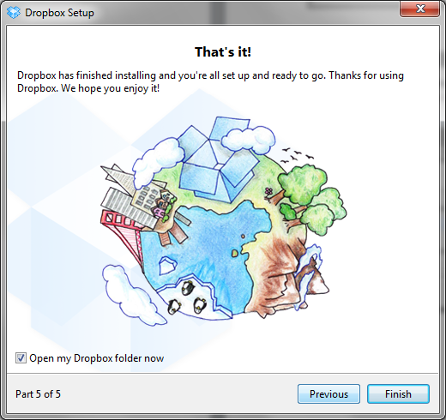 | This is the end of the Guided Tour

Creating an IAW 171 folder

When you first open Dropbox you will have two folders Public and Photos.
At this point you will need to create a folder for the Unit. Perhaps name it IAW 171.
Go to FILE →New→Folder
Name your folder

File
New
Folder

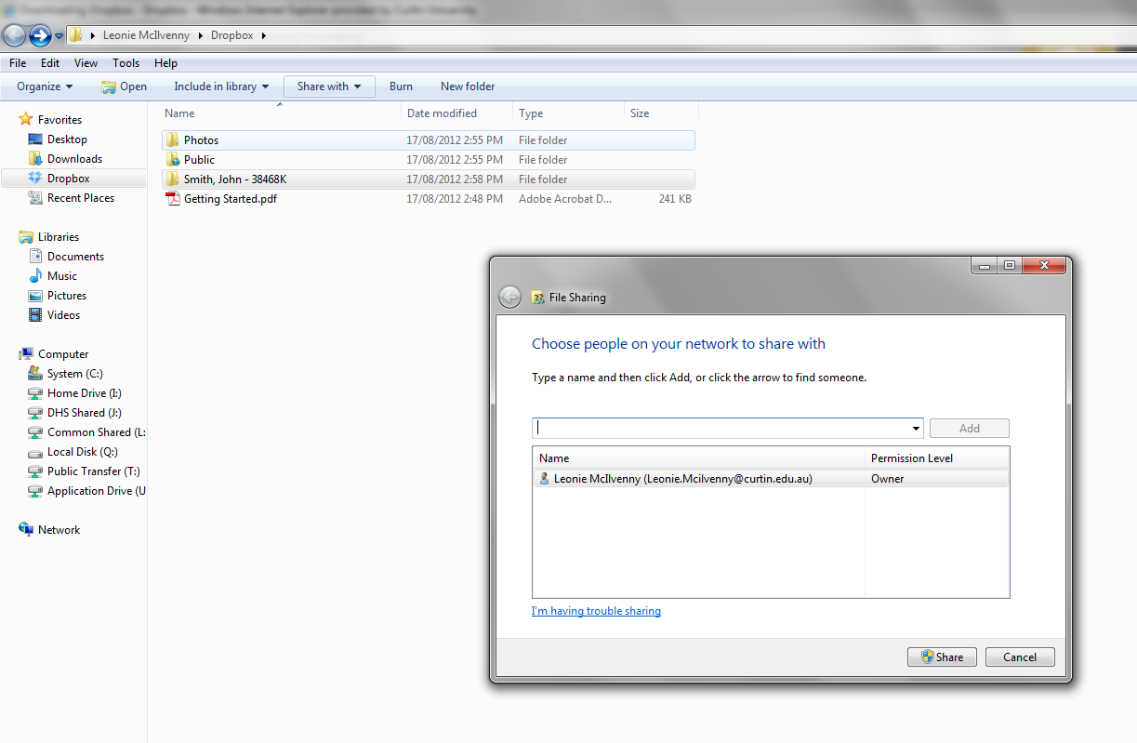 | Sharing your folder with your Tutor or other studetns  If you are working with others you may need to share the folder.To do this you must:  - Select the folder you wish to share.  - Go to the Share with button on the tool bar at the top.  - A window will open asking to place the email addresses of the people you wish to share with.  - Use the email address of the person you wish to share the folder with.  - An invitation will then be sent to that person to share the file.

