A Step-by-step guide to setting up your Drop BoxPrtfolio
for EDP260 for Teachers
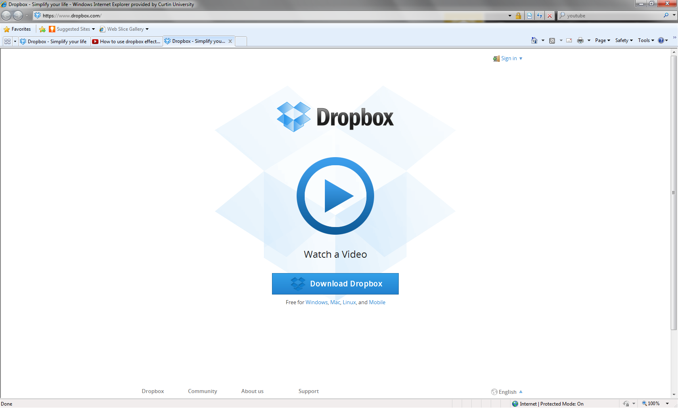 | Creating your DropBox Account  Go to www.dropbox.com  Wath the introductory video to give you an ovedrview of DropBox
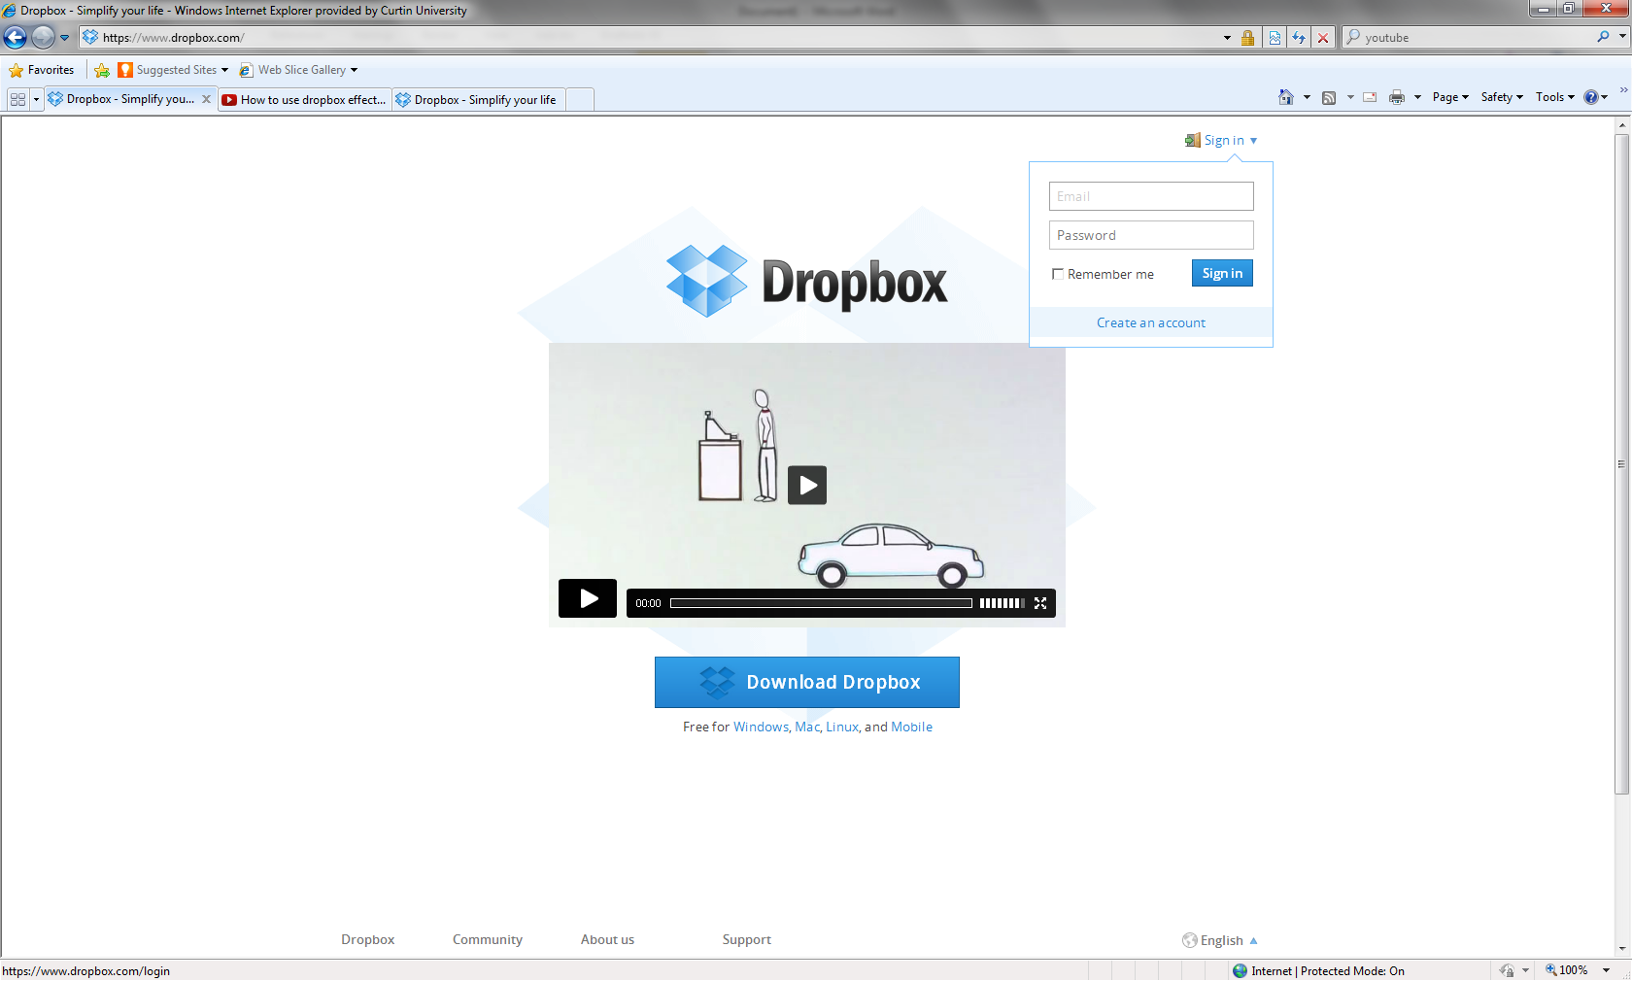 | Go to the sign in section and click on Create an Account
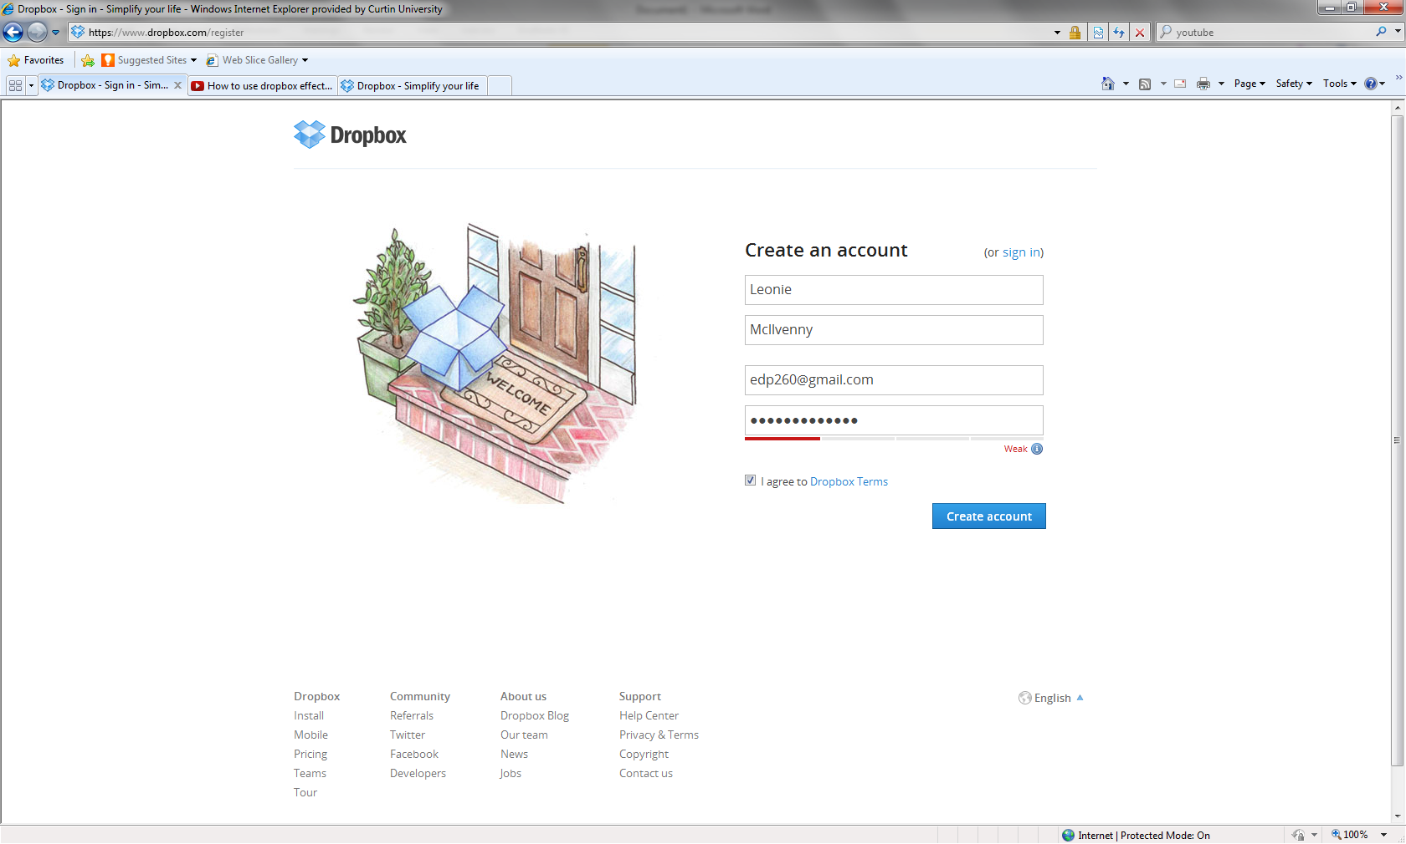 | Fill in your Registration details
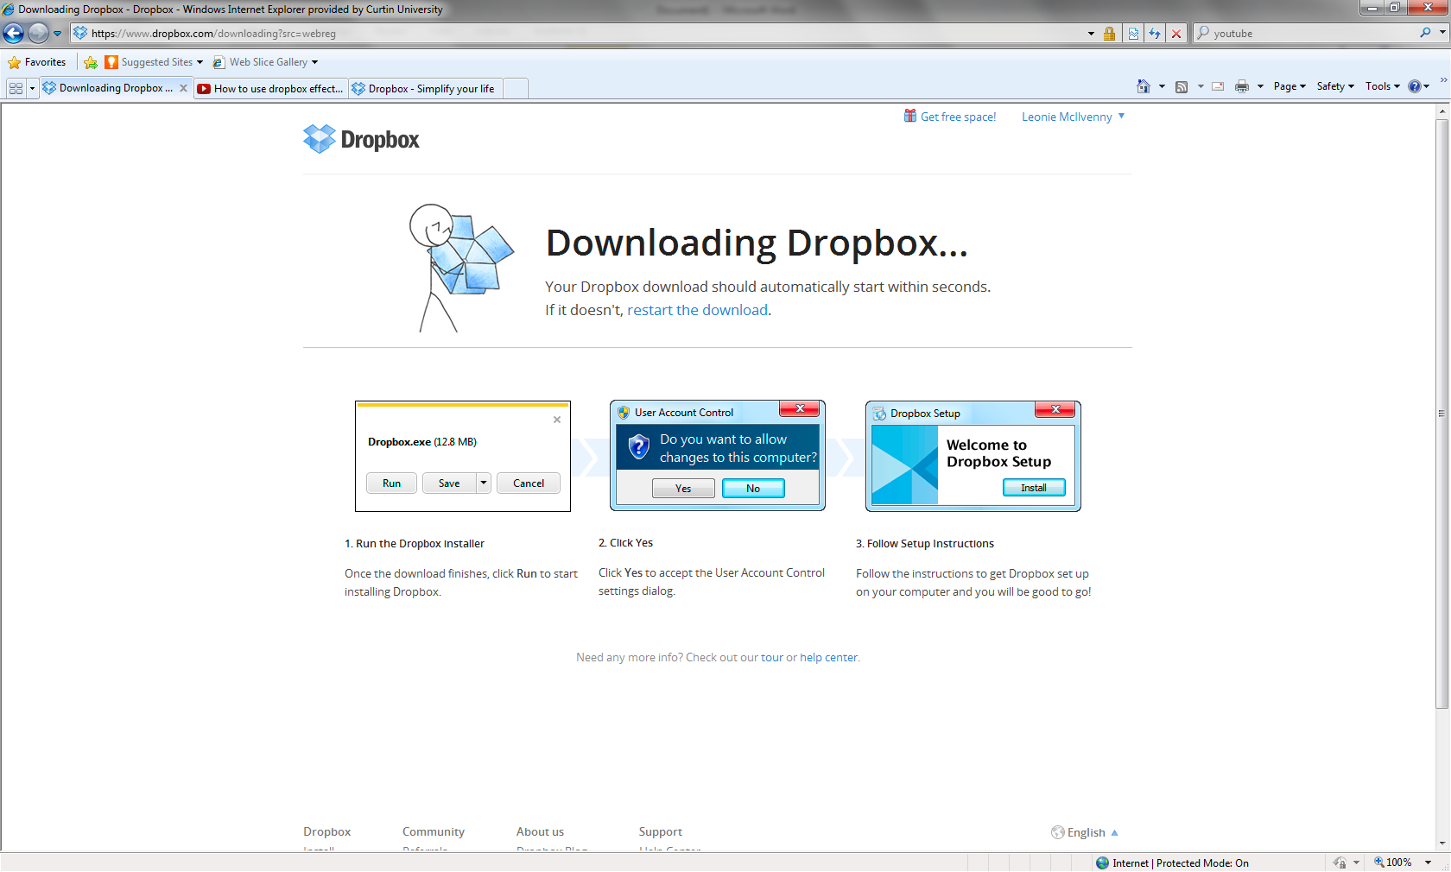 | Installing Dropbox on your computer  Follow the prompts to install DropBox on your computer

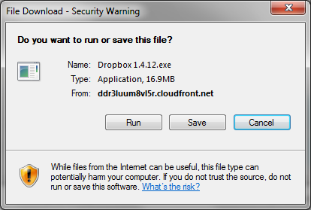 | Select RUN to install Dropbox on your computer
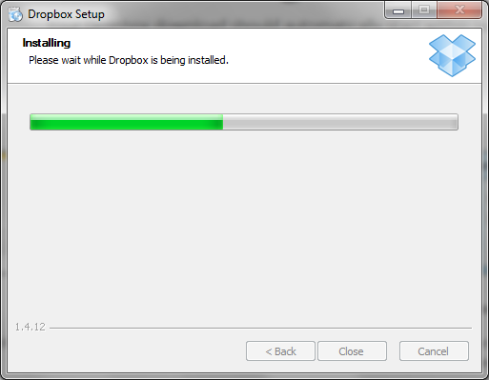 | The system will show the progress of the installation.  Once Dropbox is installed it may appear:  as an icon either at the bottom of your screen  in the Finder menu of Apple under your Applications  or a a Favourite on the your PC
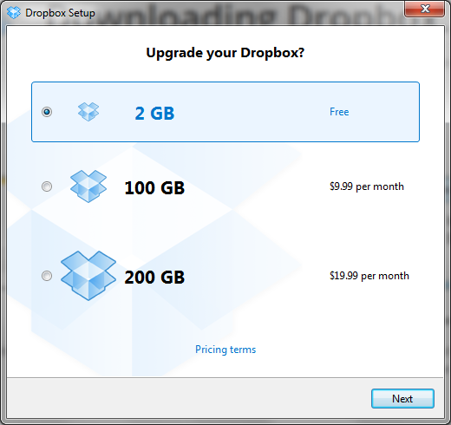 | Opening Dropbox  When you click on the Dropbox icon you will be given the option of choosing how much storage space you would like. Select 2gb as ithis will be enough for the unit (you can buy more space at a later date if you wish).
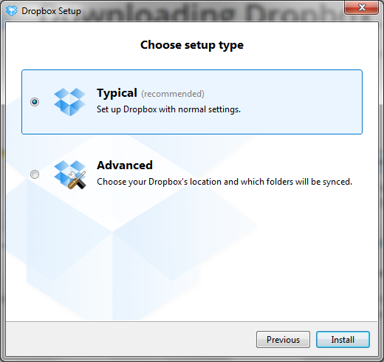 | Select Typical set up type

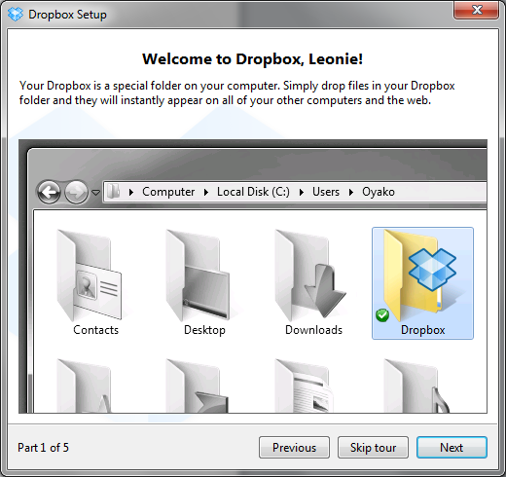 | A Guided Tour  These next windows are part of the guided tour to show you a bit about Dropbox – you can skip them if you wish.
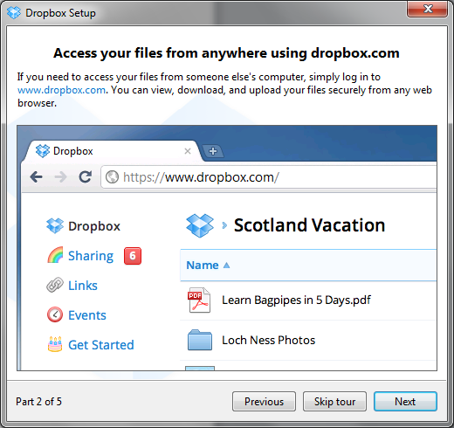

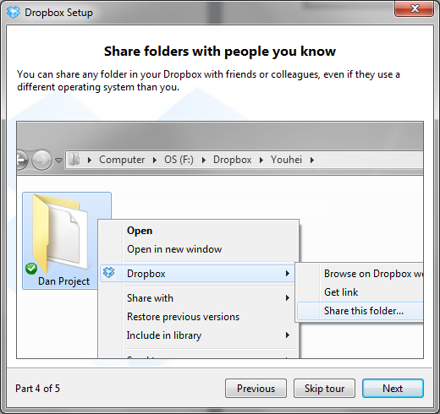

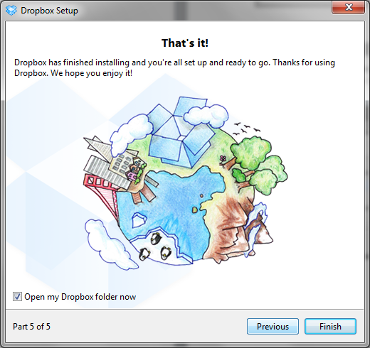 | This is the end of the Guided Tour

Creating an EDP260 folder

When you first open Dropbox you will have two folders Public and Photos.
At this point you will need to create a folder for EDP260
Go to FILE →New→Folder
Name your folder

File
New
Folder
Naming your folder

Name your folder in the following way.

Surname, First name – Student ID
For example
Smith, John – 458367H
Comments Document
Inside this folder you will need to create a Word Document called Comments. This is the document where your tutor will provide feedback to you about your portfolio throughout the semester.

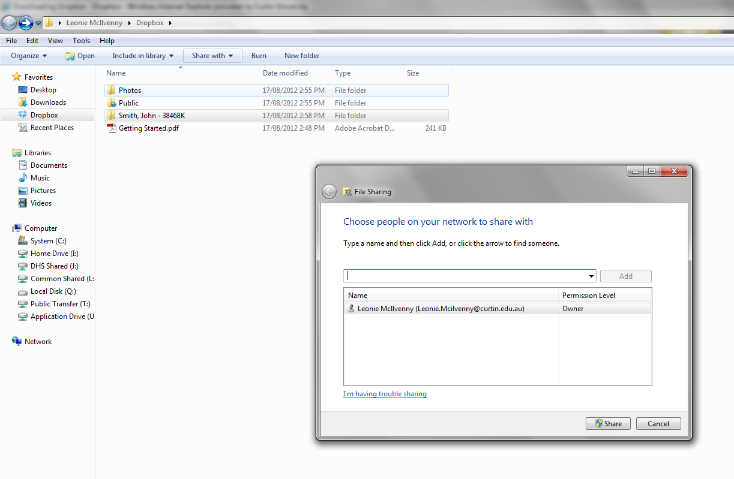 | Sharing your folder with your Tutor  Once you have created your folder you now need to share it with your tutor. To do this you must:  - Select the folder you wish to share.  - Go to the Share with button on the tool bar at the top.  - A window will open asking to place the email addresses of the people you wish to share with.  - Use the email address  edp260curtin@gmail.com  - An invitation will then be sent to the unit co-ordinator to share the file.
What to put in your EDP260 folder

Your EDP260 folder must only contain the following items:
Your portfolio items (named correctly)
The comments document for your tutor to make comments. No other document sshould be in this folder unless requested buy your tutor.

Once this process is complete your tutor and the unit co-ordinator will be able to access your portfolio. They will be able to view and make comments on your work. The Comments document will be used for any correspondence. Make sure you check this file regularly. You will be able to see when it was last updated in the Date Modified column.

